Basic Commands in Linux

1) Commands are actually files containing programs, often written in C. How will you find out in which directory does the file corresponding to the man command resides?

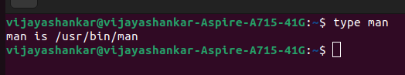
2) How will you find out what is the use of the ps command.
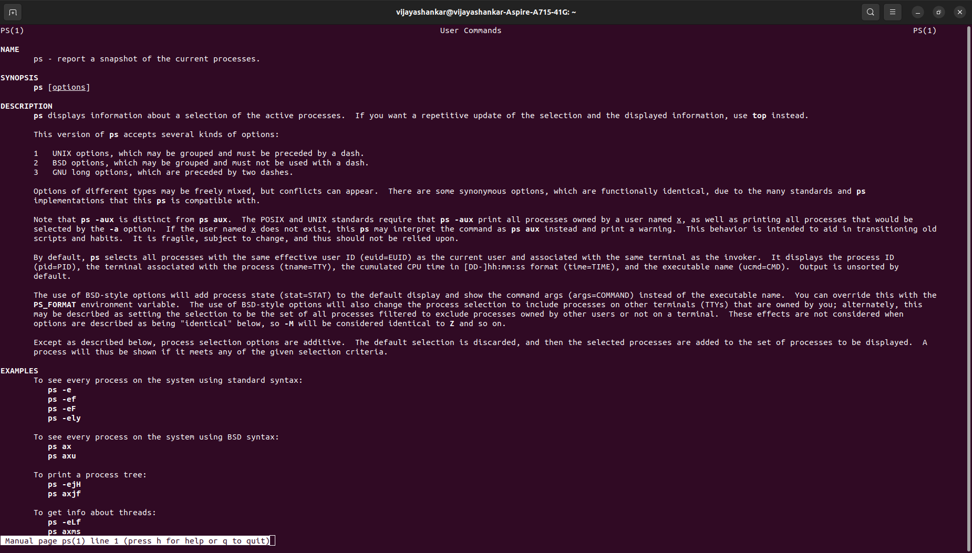

General Purpose Utilities in Linux

1)Display the calender for the month of March 2012

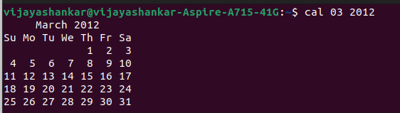

2)List all the files and directories of the directory /usr/lib on the terminal. Now put the same information in a file named results.
Display the contents of the file results now.
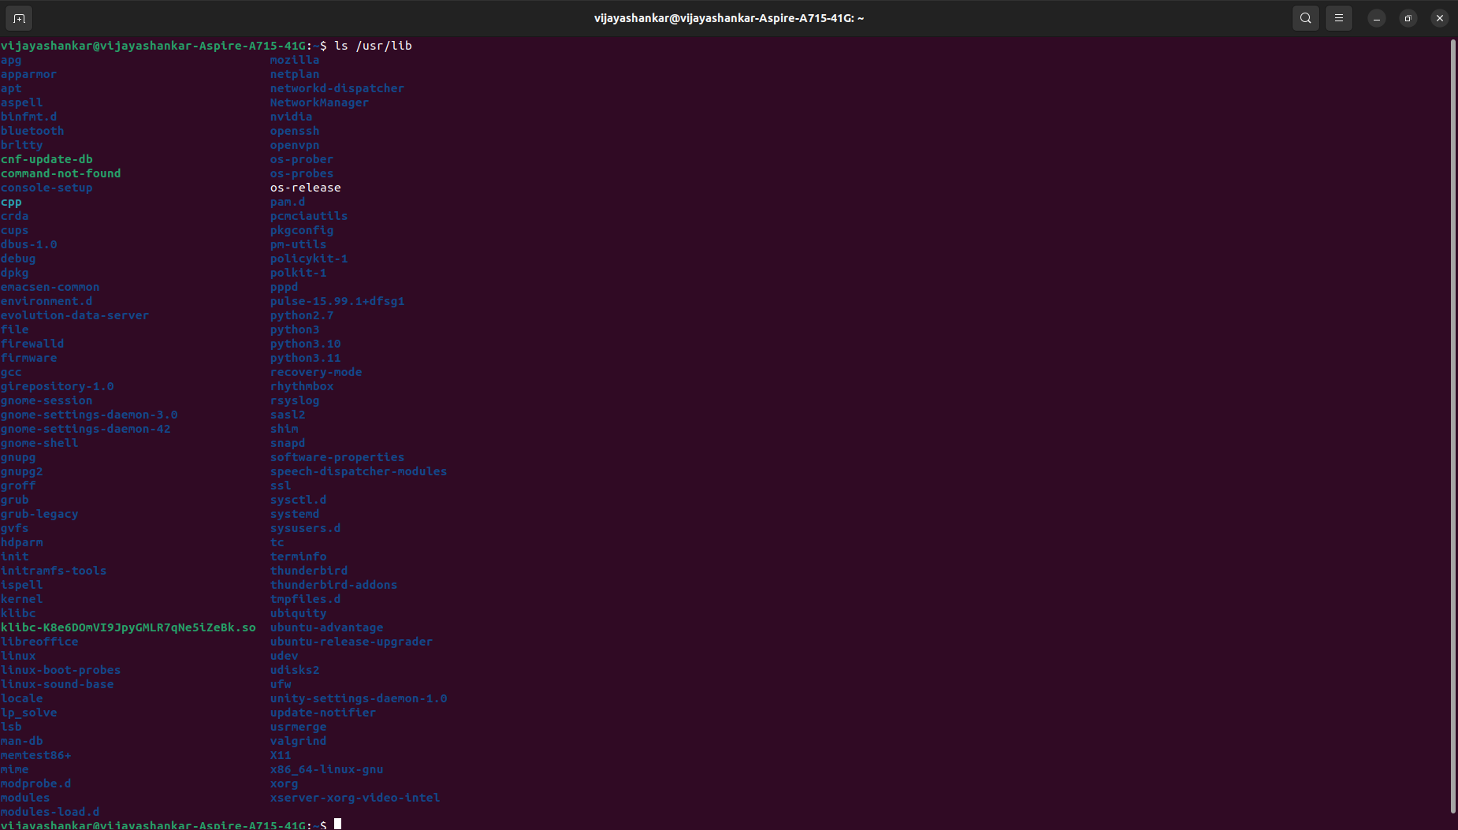

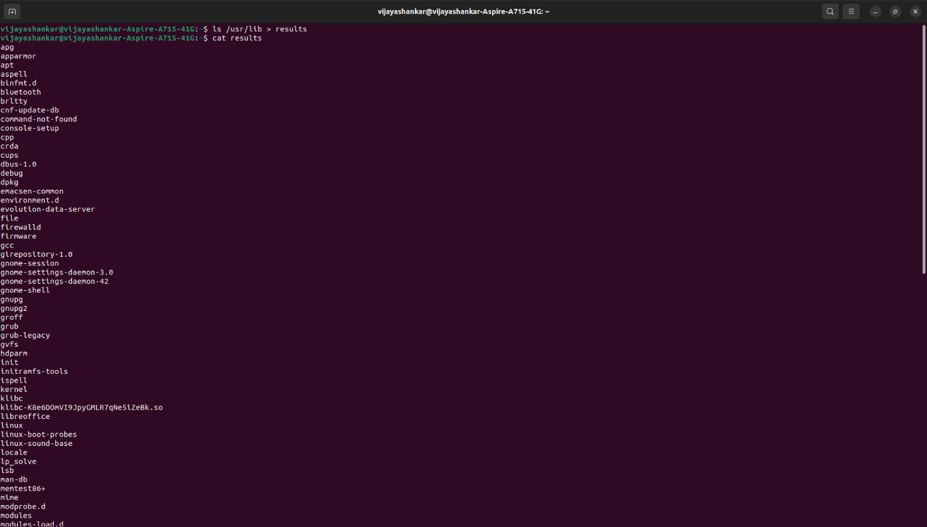
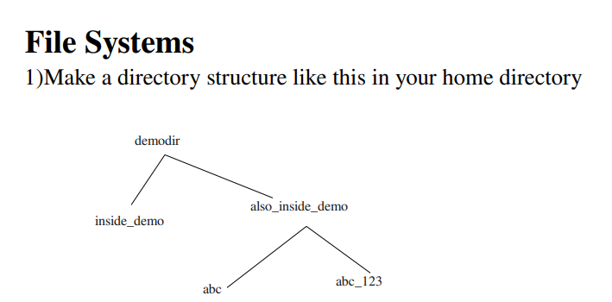
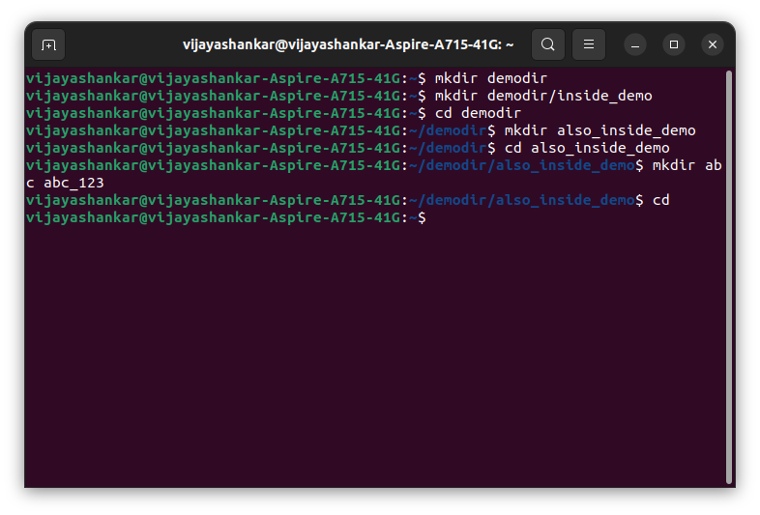
2) Remove the also_inside_demo directory

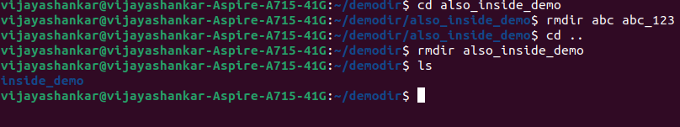

File Attributes

1. Create a file abc.txt and change the ownership of this file to some other user on your machine,
and also change the group to family.
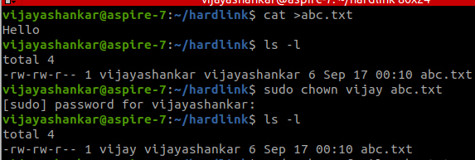

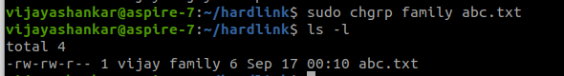

2. Create a file exercise.txt and make it executable.

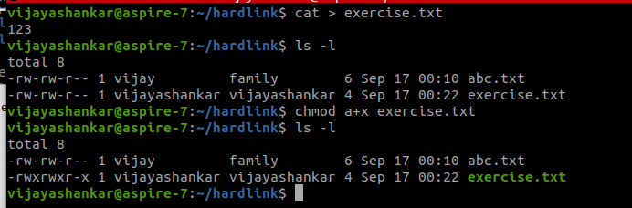

3. Create a file test.txt on your desktop and identify its inode number, also create a softlink
for test.txt in your home.
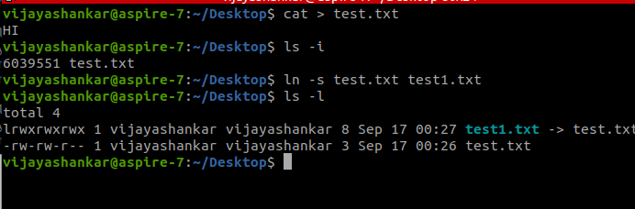
Redirection of Pipes

1. Create a file name error_log in your current directory. Suppose you do not have any file named aa11 in your current directory.
How can you redirect the error message to the file error_log when we apply the command "wc -l aa11" ?
How can you ensure that all the error log are appended to the error_log file?
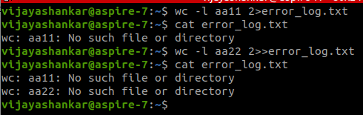

2. Create files named test1, test2, testa, testb
How can you count the number of files starting with test and then having only one digit in their name using only a single line command ?

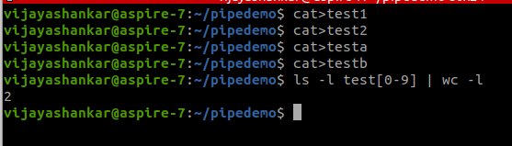
Linux process

1. Open a terminal. Now spawn three shell processes one after another i.e. first spawn one shell, then from the spawned shell, spawn one new shell and so on. Now,
how can you see the PID of the current shell ? How can you see the PID of the shell which is the grandparent of the current shell?
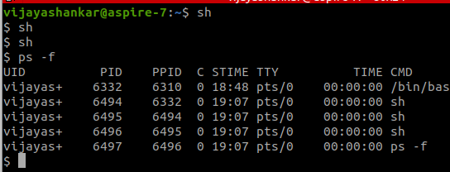
2. How can you see all the processes (both system & user processes) in your computer?
The output can be quite large. How can you view the output as multipage output ?
How can you store the output in a file named process_info?
